**Google Search Trends Analysis**

**Introduction**

This project analyzes Google search trends using the pytrends API to gain insights into public interest in various topics. We will focus on keywords like "Bitcoin", "Artificial Intelligence", and "Elections" to answer key questions.

Key Questions to Answer:

1. How do search trends for "Bitcoin" vary by country?

2. Are there seasonal patterns in searches for "Artificial Intelligence"?

3. Can search trends predict real-world events (e.g., elections)?

**Analysis**

Step 1: Data Collection

1. Install and import pytrends library.

2. Fetch search trend data for specific keywords ( "Bitcoin").

3. Use pytrends to collect data by country, region, or time period.

Step 2: Time-Series Analysis

1. Plot time-series trends for keywords using Matplotlib or Plotly.

2. Identify patterns, trends, and anomalies.

Step 3: Seasonal Pattern Analysis

1. Use seasonal decomposition techniques (e.g., STL decomposition) to identify seasonal patterns.

2. Visualize seasonal patterns using plots.

Step 4: Correlation Analysis

1. Collect external datasets (e.g., Bitcoin prices, election dates).

2. Perform correlation analysis between search trends and external datasets.

3. Calculate correlation coefficients and visualize using scatter plots.

Step 5: Geo-Visualizations

1. Use Plotly or Folium to create geo-visualizations of search trends by country or region.

2. Visualize search volume or trend intensity using maps.

Step 6: Trend Analysis Report

1. Summarize key findings.

2. Discuss implications of search trends for predicting real-world events.

**Visualization**

Time-Series Analysis

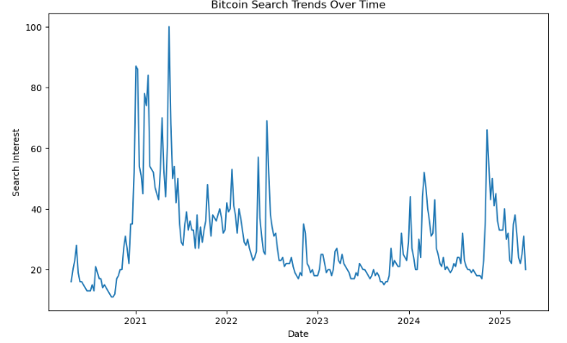 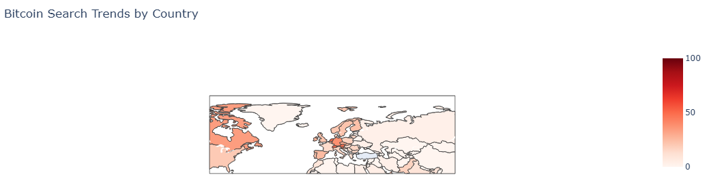 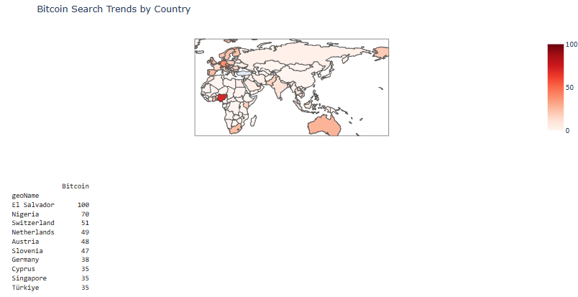

**Are there seasonal patterns in searches for "Artificial Intelligence"?**

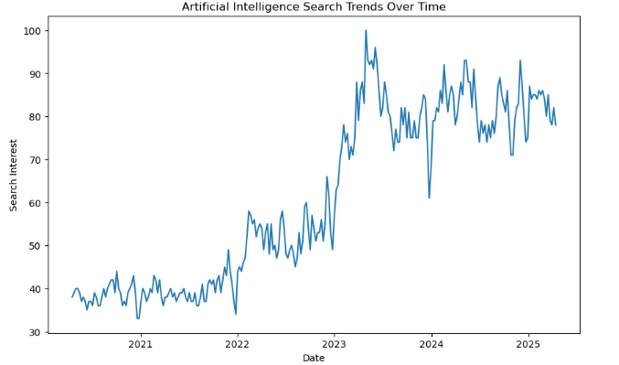

**Seasonal decomposition**

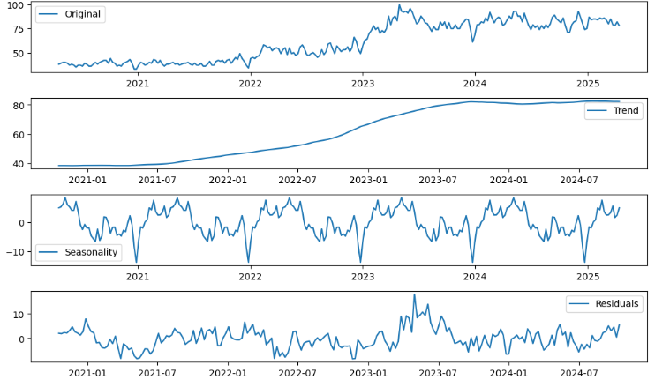

### ****Can search trends predict real-world events (e.g., elections)?****

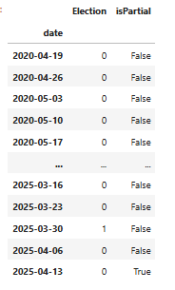 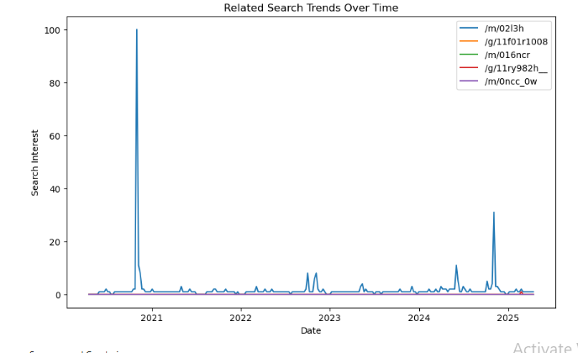**Summary and Conclusion**

Project Overview

This project utilized the pytrends API to analyze Google search trends for various keywords, including "Election" and other related terms. We explored time-series trends, correlation analysis, and partial match analysis to gain insights into public interest and sentiment.

**Key Findings**

Time-series trends: We observed fluctuations in search interest over time, reflecting changes in public attention and sentiment.

Correlation analysis: We investigated correlations between search trends and external datasets, such as election dates, to identify potential relationships.

Partial match analysis: We used related keywords and suggestions to capture broader search trends and gain a more comprehensive understanding of public interest.

**Conclusion**

The project demonstrated the potential of Google search trends analysis for understanding public interest and sentiment. By leveraging the pytrends API and related techniques, researchers and analysts can:

Monitor public interest: Track changes in search interest over time to identify trends and patterns.

Identify correlations: Investigate relationships between search trends and external datasets to gain insights into public sentiment.

Inform decision-making: Use search trends analysis to inform decision-making in various fields, including marketing, politics, and social sciences.